Red Hat Social Butterflies

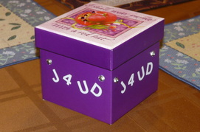
“J4UD” [Just 4 You Day]

This is "our" day of no fuss-no RSVP-no planning-just an easy, cheap, fun, chatting, CC** get together lunch at different "fast food" places around the Long Beach area. We will meet every 3rd Tuesday of the month for a casual short lunch.

At every lunch we will pick a restaurant out of our “J4UD” box and that will be the next place we will meet. [Ex: pick in July = Sept, Aug=Oct, Sept=Nov..ect…]
Wear you "CC" [Casual Colors] remember NO RSVP needed, just show up any time between 11:30am -1:30pm and join other Red Hat Sisters when you can and enjoy Red Hat Social Butterflies Sisterhood!

**Casual Colors:[CC] casual purple top and something "red" on your head [Pink Hatter- Lavender top & Pink on your head]

