OLD TOWN TROLLEY WINE TOUR

Friday Night, July 14 @ 5:45PM
606 East Chapman Avenue, City of Orange
Trolley leaves at 6PM sharp-you’re late you lose.

$50 per person. Only 26 seats. First come, first served.
Checks must be received by May 12, 2017
Hostesses: Lucinda Swan and Diana Gunzel
Send checks to: Diana Gunzel 11869 Geode Eve in Fountain Valley 92708

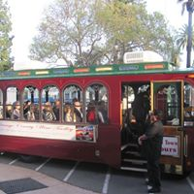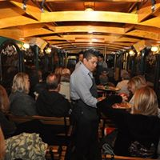
Tour Old Towne Orange in an Enclosed Trolley. Learn the unique facts and history of the town, while enjoying approximately 7 different wines and food from 11 distinguished restaurants, all served to you on the trolley during the tour.

