~Social Butterflies - Vintage Babes -Twilight Girls~
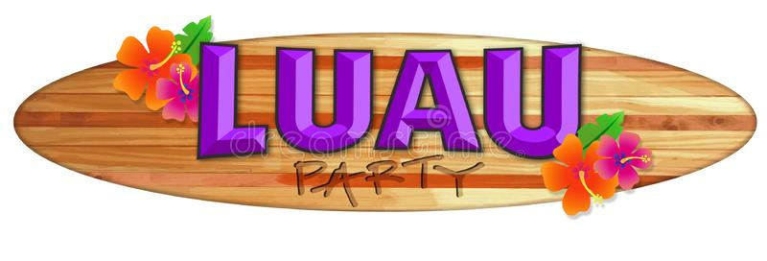
Hawaiian LUAU PARTY

July 25th, 2020
11:00am – 2:30pm
Leisure World Club House #2
13533 Seal Beach Blvd, Seal Beach, CA 90740
Best Hawaiian Regalia Contest– 3 Winners
[Red Hat Colors] ~SisterHood~
~PRIZES ~ 50/50 Raffle~
~includes food dessert & games~
~Learn to do the HULA dance ~music
Cost $35.00
RSVP: QM Debb queenmumdebb@gmail.com [562]756-1556 or Pat Staley patt5150@aol.com [562]714-7004 Make checks out to Social Butterflies
RHS Members

Aloha Hawaiian Luau Party ~ July 25th, 2020, 11:00am-2:30pm
~Social Butterflies ~ Vintage Babes ~ Twilite Girls~

Please include this form when sending in your checks.
Make checks out to Social Butterflies and mail to:
QM Debb, 1310 Stevely Ave, Long Beach, CA 90815
Fill out and return with your check made out to Social Butterflies
$35.00
Date ________________________________________________ Check #_________________
Your Name__________________________________________________________________________
Address _______________________________________________________________________________
________________________________________________________________________________
Phone #______________________________________________________
Email/Phone #___________________________________________________________________
Membership #___________________________
Chapter Name___________________________________________________________________________
Queen’s Name & Email___________________________________________________________________________
Ladies Attending__________________________________________________________________
_______________________________________________________________________________________
_______________________________________________________________________________________

***
Self-Seating ~ Red Hat Regalia Colors
~No Refunds ~ Transferrable ~For RHS Supporting Members~
Please provide proof of membership when registering [copy of membership card] for this event as well as "at the door".
Your Member ID Card can be printed off the RHS
website page: hover over “CONNECT click on > MY ACCOUNT >
MEMBERSHIP INFORMATION > PRINT/VIEW MY MEMBERSHIP CARD”

